**DOWNLOAD MY HEALTH INFORMATION**

The **Download My Health Information** tab feature allows you to download your health information in a simple, automated manner.

NOTE: Download and save your data only on computers and networks you know and trust, such as your own PC at home.

## Download My Data

Select a date range and then click one of the **Download My Data** buttons (**CCD** for use with other Electronic Health Records, or **Plain Text** for a readable text file).

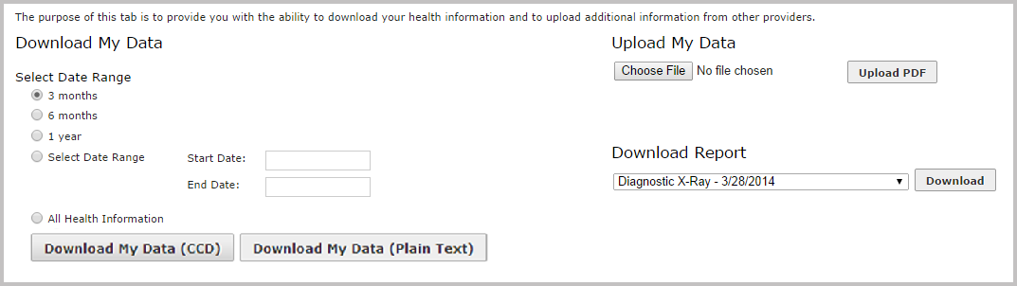

The export will be downloaded to your Downloads folder. CCDs files are generally used by other healthcare information software packages. A plain text file can be opened and viewed in Windows Notepad or most document editors.

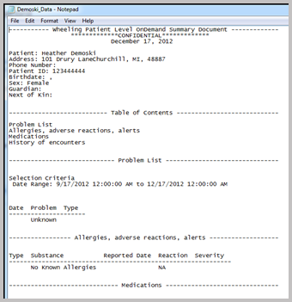

## Download Report

Any patient reports in the HIE which the user has permission to access can also be downloaded to a local machine.

Select a PDF or .txt file from the dropdown list under *Download Report*, and then click the **Download** button.

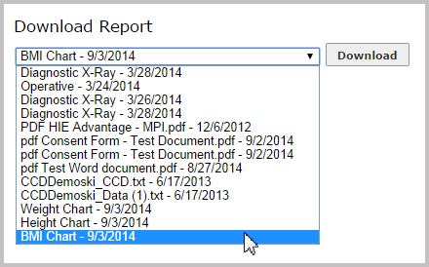

## Upload My **Data**

For users wishing to add records (such as forms or consents) not already contained within their HIE record, there is also the option to upload PDF documents.

To begin, click **Choose File** to select a file located on your computer, then click **Upload PDF** to begin the file transfer. Once the upload is complete, a notification and a link to the document will appear.

